

Topic test 2
Name: __________________________________

Chapter 8: Arithmetic and geometric sequences

• Time allowed: 45 minutes
• CAS calculators may be used.
• Part A: 5 multiple-choice questions (5 marks)
• Part B: 8 short answer questions (16 marks)
• Part C: 2 analysis questions (6 marks)
Part A
5 multiple-choice questions
1 mark each: 5 marks
Circle the correct answer.
1 How many terms are in the sequence 23, 32, 41, …, 203?
A 4
B 21
C 23
D 41
E 203

[1 mark]
2 How many terms are in the sequence −645, 215, 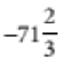, …, 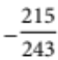?
A 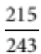
B 4
C 7
D 8
E −645

[1 mark]
3 What is the first term that is less than zero in the series 301 + 289 + 277 + ∙ ∙ ∙ ?
A 0
B −1
C −11
D −12
E 26

[1 mark]
4 Find S8 − S7 for the geometric series 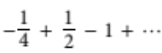
A 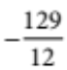
B 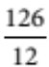
C 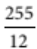
D 16
E 32

[1 mark]
5 What is the limiting sum of 8 − 4 + 2 − 1 + ∙ ∙ ∙ ?
A
B 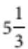
C 8
D 15
E 16

[1 mark]

Part B
8 short answer questions
16 marks
Show your working where appropriate.
1 Evaluate to 10 terms: 1 + 3 + 5 + 7 + ∙ ∙ ∙

[2 marks]
2 Evaluate to 6 terms: 19 + 21 + 23 + ∙ ∙ ∙

[2 marks]
3 For an AP with first term a, common difference d and n terms, write an expression for Sn + 1.

[2 marks]
4 Insert an expression between the pair of variables p, q to form a geometric sequence.

[2 marks]
5 Find S∞ for the geometric sequence 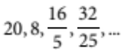

[2 marks]
6 How many terms of the arithmetic sequence 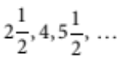 must be taken for the sum to be
greater than 200?

[2 marks]
7 Find the value of x such that (3 − x), x, (2 − x) are successive terms of a geometric sequence.

[2 marks]
8 Write 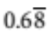 as a simplified fraction. Show all working.

[2 marks]
Part C
2 analysis questions
6 marks
Show your working where appropriate.
1 Jenny has invested $24 000 at 9% compounding annually. How much will her investment be worth after
10 years?

[2 marks]
2 Alan invested $100 each month for 20 years towards his superannuation.
His investment earned compound interest at a rate of 9% per annum paid monthly.
a How much did he invest over this time?

[1 mark]

b What was the value of his investment after 20 years?

[3 marks]
Total marks: 27
Answers
Part A [1 mark each]
1 tn = a + (n − 1)d, 203 = 23 + (n − 1) × 9, n = 21.
 B [1 mark]
2 tn = ar n⁻1, 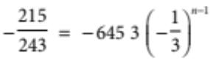, by trial and error n = 7.
 C [1 mark]
3 tn < 0, 301 + (n − 1) × (−12) < 0, 12n > 313, n > 26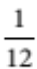, n = 27. [ t27 = −11
 C [1 mark]
4 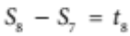, 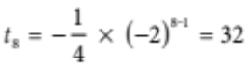
 E [1 mark]
5 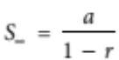, 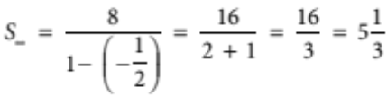
 B [1 mark]
Part B
1 1 + 3 + 5 + ∙ ∙ ∙ + 19 [1 mark]
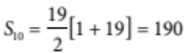 [1 mark]
2 S = S15 − S9 [1 mark]
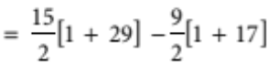
= 144 [1 mark]
3 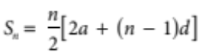
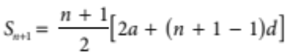 [1 mark]
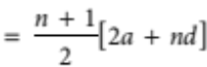 or equivalent [1 mark]
4 Since p, x, q form part of a geometric sequence, a common ratio exists.
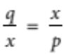 [1 mark]
x2 = pq
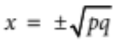 [1 mark]
5 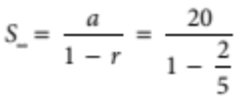 [1 mark]
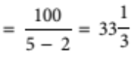 [1 mark]
6 Sn > 200
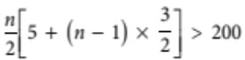 [1 mark]
3n2 + 4n − 800 > 0
n > 15.68, n < −17.01
Since n > 0, n = 16 [1 mark]
7 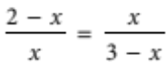 [1 mark]
x2 = (2 − x)(3 − x)
Solving for x, we get 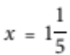 [1 mark]
8 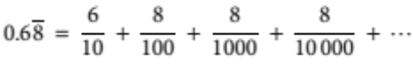 [1 mark]
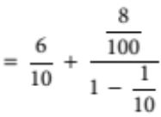
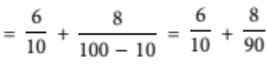
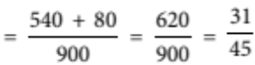 [1 mark]
Part C
1 Investment = (24 000 × 1.09) × 1.09 × 1.09 × ∙ ∙ ∙ × 1.09 [1 mark]
= 24 000 × 1.0910
= $56 816.73 [1 mark]
2 a Total outlay = 100 × 240 [1 mark]
b Superannuation = 100 × 1.0075 + 100 × 1.00752 + 100 × 1.00753 + ∙ ∙ ∙ + 100 × 1.0075240
= 100 × (1.0075 + 1.00752 + 1.00753 + ∙ ∙ ∙ + 1.0075240) [1 mark]
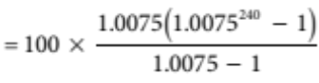 [1 mark]
= $67 289.60 [1 mark]

